Name

Mathematics Advanced Year 11
Circles, Semicircles, Square Root Function

Book 1 |  | Version: 261020  Feedback:  https://MrDingMaths.com
Contents
Syllabus Content 2
Learning Intention 3

Syllabus Content
MAV-11-02 uses functions and relations to model, analyse and solve problems
Circles and semicircles
- Derive the equation of a circle of radius $r$ with centre at the origin by considering Pythagoras’ theorem
- Graph circles of the form $x^{2}+y^{2}=r^{2}$ from their equations
- Determine the equation of a circle of the form $x^{2}+y^{2}=r^{2}$ given its graph
- Identify and graph the semicircles $y=\sqrt{r^{2}-x^{2}}$, $y=-\sqrt{r^{2}-x^{2}}$, $x=\sqrt{r^{2}-y^{2}}$ and $x=-\sqrt{r^{2}-y^{2}}$

Circles at the Origin

- Investigation Equation of a Circle
Consider the following circle with radius $r$ centred at the origin $(0,0)$
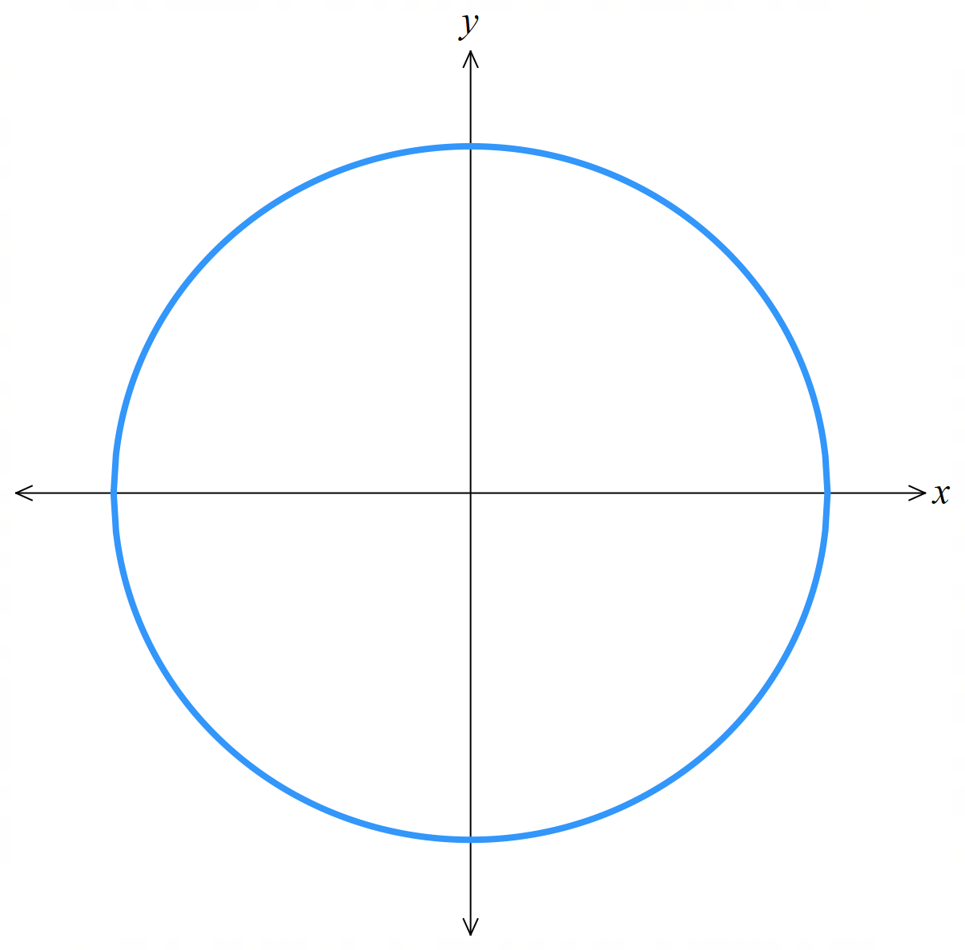

1. Choose a point on the circumference. Label this $P(x,y)$

2. Draw a line segment from the centre to the point $P$.
What is the length of this line and what is it called? …………………………………

3. Construct a right-angled triangle using the radius as the hypotenuse.
Label the lengths of the sides.

4. Write an equation relating the three sides of the right-angled triangle.
…………………………………………………………………………………………………………
This is the equation of a circle.

- Equation of a Circle Centred at the Origin
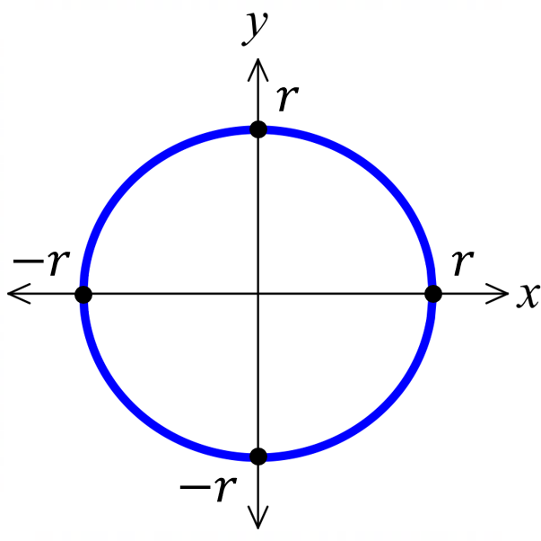

$$x^{2}+y^{2}=r^{2}$$
radius $r$

- Sketch the graph of a circle centred at the origin
Sketch $x^{2}+y^{2}=16$  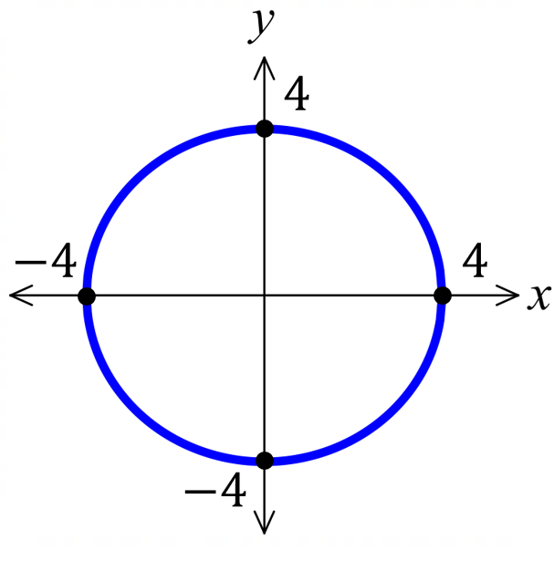 |  | Sketch $x^{2}+y^{2}=$ $\frac{4}{9}$  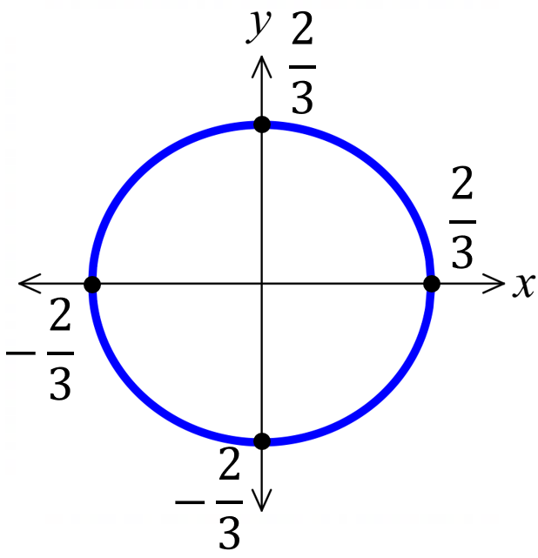
Sketch these circles
- $x^{2}+y^{2}=36$ | - $x^{2}+y^{2}=37$ |  | 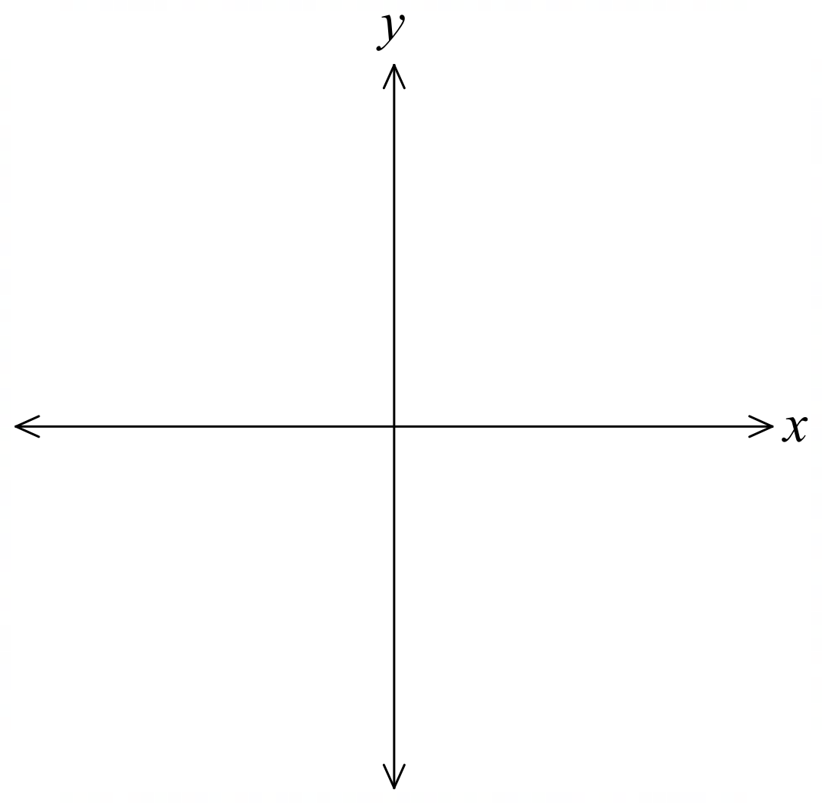  - $x^{2}+y^{2}=$ $\frac{1}{4}$
- $x^{2}+y^{2}=$ $\frac{9}{4}$ | - $x^{2}+y^{2}=144$ |  | - $x^{2}+y^{2}=7^{2}$

Foundation
- Identify the radius of the circles with these equations:
- $x^{2}+y^{2}=36$  6 | - $x^{2}+y^{2}=81$  9 | - $x^{2}+y^{2}=144$  12
- $x^{2}+y^{2}=5$  $$\sqrt{5}$$ | - $x^{2}+y^{2}=12$  $$2\sqrt{3}$$ | - $x^{2}+y^{2}=\frac{1}{4}$  $$\frac{1}{2}$$
- Write the equation of a circle with centre at the origin and radius of:
- $4$  $$x^{2}+y^{2}=16$$ | - $7$  $$x^{2}+y^{2}=49$$ | - $100$  $$x^{2}+y^{2}=10000$$
- $\sqrt{6}$  $$x^{2}+y^{2}=6$$ | - $\sqrt{10}$  $$x^{2}+y^{2}=10$$ | - $1.1$  $$x^{2}+y^{2}=1.21$$

- Sketch these circles showing the centre and all intercepts.
- $x^{2}+y^{2}=49$  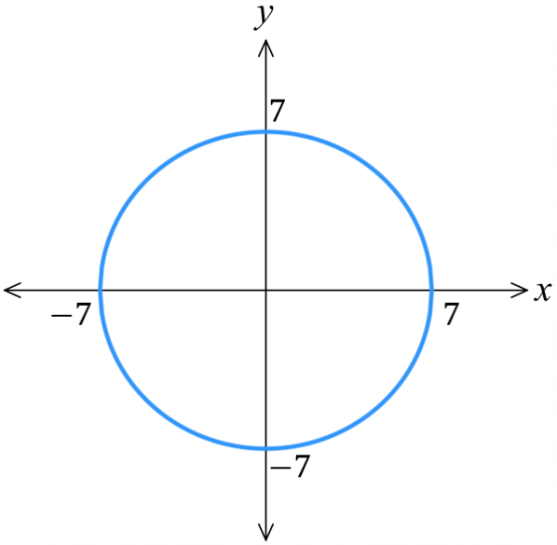 | - $x^{2}+y^{2}=$ $\frac{1}{9}$  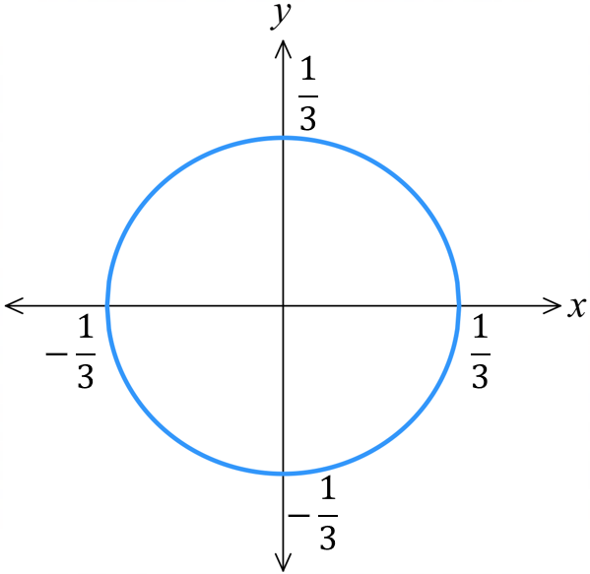  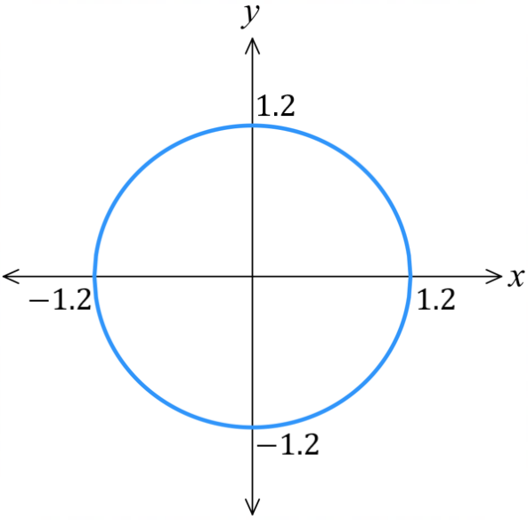  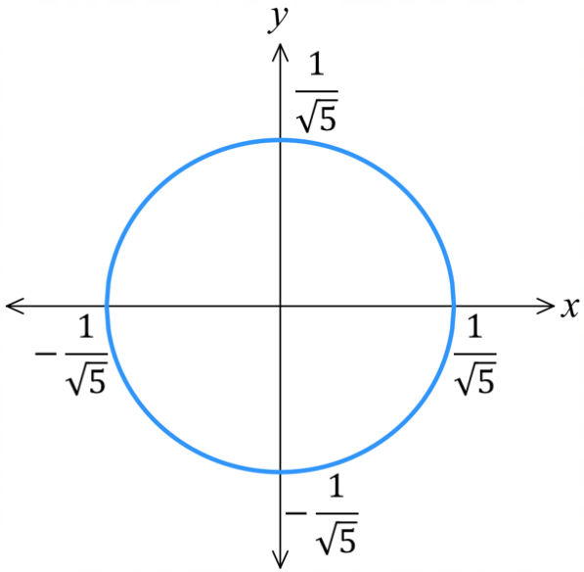 | - $x^{2}+y^{2}=1.44$
- $x^{2}+y^{2}=$ $\frac{9}{4}$  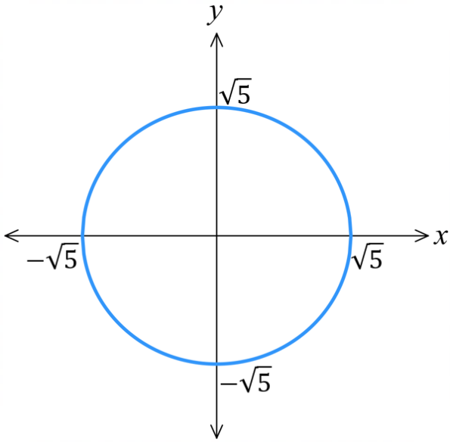  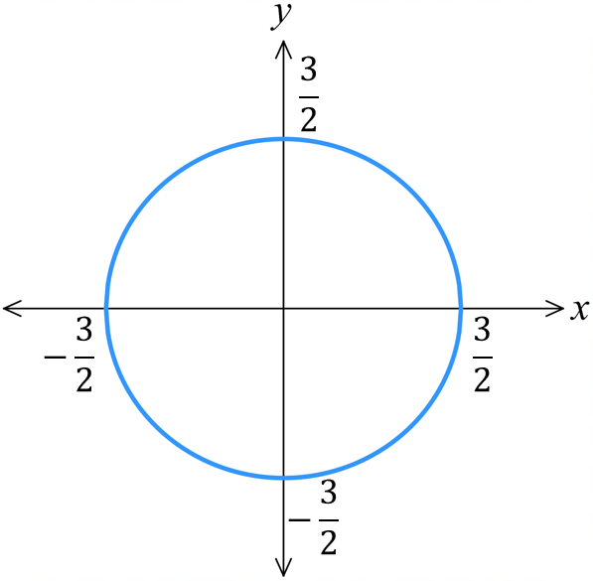 | - $x^{2}+y^{2}=5$ | - $x^{2}+y^{2}=$ $\frac{1}{5}$

Development
- Determine the equation of each circle. They are all centred at the origin.
$$x^{2}+y^{2}=4$$ | 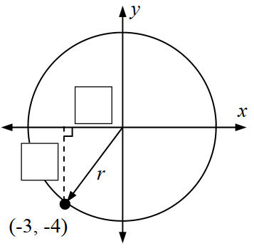  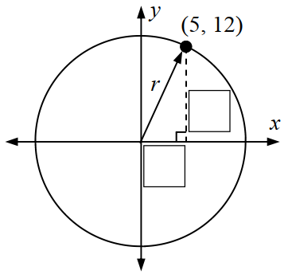  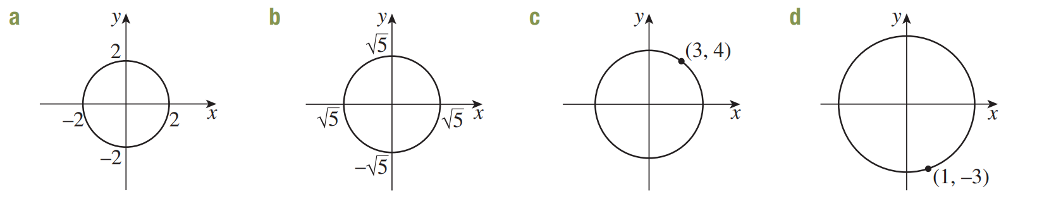  $$x^{2}+y^{2}=5$$
$$x^{2}+y^{2}=169$$ | $$x^{2}+y^{2}=25$$
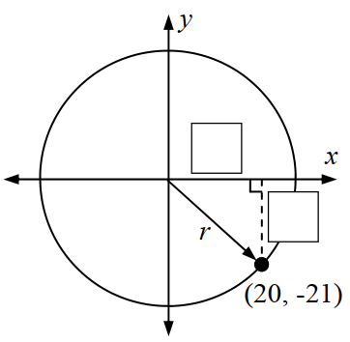  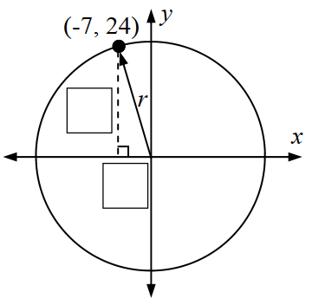  $$x^{2}+y^{2}=625$$ | $$x^{2}+y^{2}=841$$
$$x^{2}+y^{2}=25$$ | $$x^{2}+y^{2}=10$$

Mastery
- A circle with centre $O\left(0, 0\right)$ passes through $A\left(5, 12\right)$.
  - What is its radius?

$$13$$
  - Therefore, what is its equation?

$$x^{2}+y^{2}=169$$
- Consider the four points $A\left(1, 4\right), B\left(2, \sqrt{13}\right), C\left(3, 2\sqrt{2}\right) and D\left(4, 1\right)$
  - Find the distance of each point from the origin O.

$\sqrt{17}$
  - Hence explain why the four points lie on a circle with centre the origin and state the equation of the circle.

Each point is equidistant from the origin, so it lies on a circle centred at the origin.
$$x^{2}+y^{2}=17$$
  - What is the radius, diameter, circumference and area of this circle?

$r=\sqrt{17}$, $d=2\sqrt{17}$, $C=2π\sqrt{17}$, $A=17π$

- Show, using substitution, that $E\left(-12, -5\right)$ lies on the circle centred at the origin with radius 13.

$$x^{2}+y^{2}=169$$
$${\left(-12\right)}^{2}+{\left(-5\right)}^{2}=144+25=169$$
- Consider points $A\left(-5,0\right), B\left(5,0\right),$and $C\left(3,4\right)$.
  - Show that the points all lie on the circle $x^{2}+y^{2}=25$.

Using distance formula, distance from origin of all 3 points is $5$
  - Show that $AC⊥BC$.
$$m_{AC}=\frac{1}{2}, m_{BC}=-2$$
Since the gradients of AC and BC are negative reciprocals, they are perpendicular.

Circle Transformations

- General Equation of a Circle
centre $\left(a,b\right)$

$${\left(x-a\right)}^{2}+{\left(y-b\right)}^{2}=r^{2}$$
radius $r$

- Identify Centre and radius from equation of a circle
$${\left(x-3\right)}^{2}+{\left(y-4\right)}^{2}=25$$  Centre $\left(3,4\right)$, Radius 5 | $${\left(x-4\right)}^{2}+{\left(y+3\right)}^{2}=36$$  Centre $\left(4,-3\right)$, Radius 6
Identify the centre and radius of these circles
- ${\left(x-3\right)}^{2}+{\left(y+4\right)}^{2}=16$  Centre ………… Radius ………… | - ${\left(x+3\right)}^{2}+y^{2}=25$  Centre ………… Radius …………
- ${\left(x+2\right)}^{2}+{\left(y-50\right)}^{2}=100$  Centre ………… Radius ………… | - ${\left(x+19\right)}^{2}+{\left(y+\frac{1}{2}\right)}^{2}=50$  Centre ………… Radius …………
Find the equation of the circle for:
- Centre: $\left(3,9\right)$, radius 4 | - Centre: $\left(-1,\frac{3}{4}\right),$ radius $\sqrt{13}$

- Sketching a Translated Circle
centre $\left(a,b\right)$

$${\left(x-a\right)}^{2}+{\left(y-b\right)}^{2}=r^{2}$$
radius $r$
1. Identify centre and radius.
2. Draw a quick sketch, using the radius to determine if it crosses the axes.
3. Find $x$ and $y$ intercepts, if any.

- Example Sketch the graph of a circle not centred at the origin
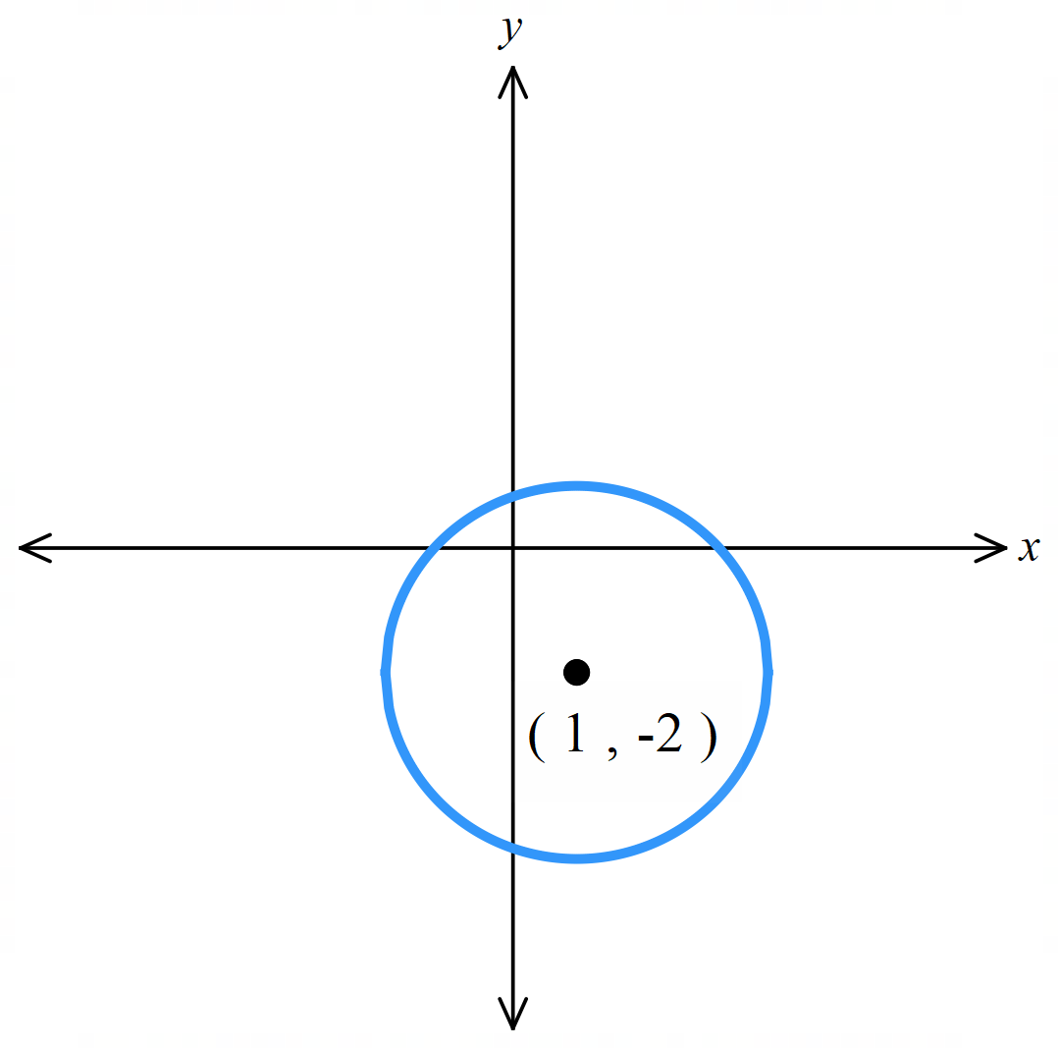
Sketch ${\left(x-1\right)}^{2}+{\left(y+2\right)}^{2}=9$.
Centre $\left(1,-2\right)$ radius 3.
The circle will cross the axes because the radius is 3.
$x$ intercepts let $y=0$  $${\left(x-1\right)}^{2}+{\left(0+2\right)}^{2}=9 \\ {\left(x-1\right)}^{2}=5 \\ x=1±\sqrt{5}$$ | $y$ intercepts let $x=0$  $${\left(0-1\right)}^{2}+{\left(y+2\right)}^{2}=9 \\ {\left(y+2\right)}^{2}=8 \\ y=-2±2\sqrt{2}$$

- Guided Practice
Sketch, and find the intercepts, if any.
- ${(x-1)}^{2}+y^{2}=1$  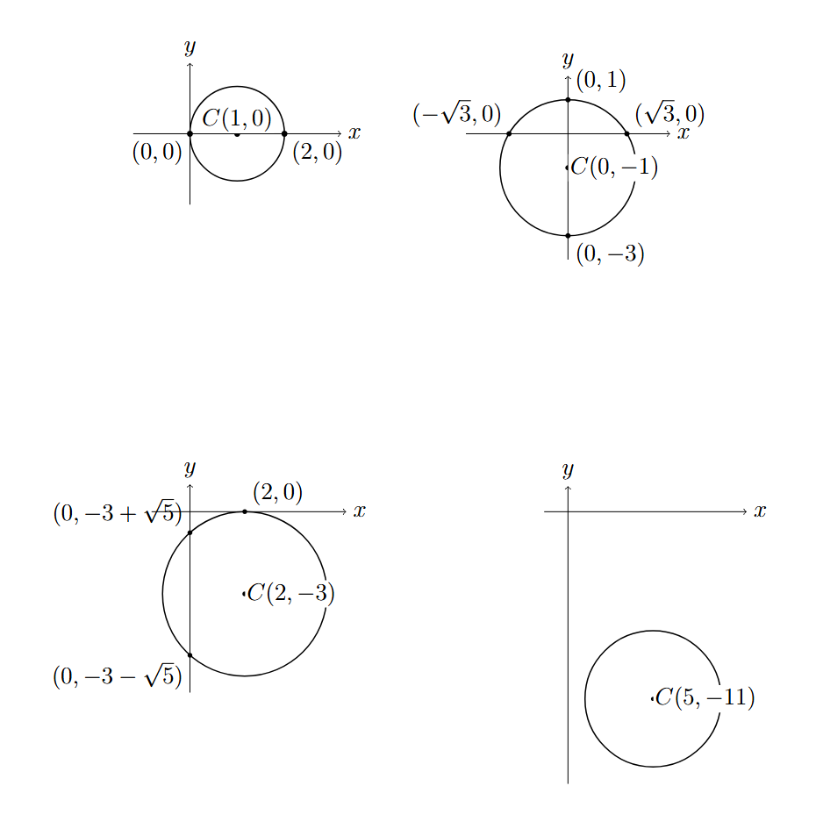 | - $x^{2}+{(y+1)}^{2}=4$
- ${(x-2)}^{2}+{(y+3)}^{2}=9$ | - ${\left(x-5\right)}^{2}+{\left(y+11\right)}^{2}=16$

Foundation
- Choose the word left, right, up or down to complete each sentence.
  - Compared to $x^{2}+y^{2}=r^{2},$ ${\left(x-1\right)}^{2}+y^{2}=r^{2}$is translated …………… by 1 unit.
right
  - Compared to $x^{2}+y^{2}=r^{2},$ ${\left(x+3\right)}^{2}+y^{2}=r^{2}$ is translated ……………………………
Left by 3 units
  - Compared to $x^{2}+y^{2}=r^{2},$ $x^{2}+{(y+3)}^{2}=r^{2}$ is translated ……………………………
Down by 3 units
  - Compared to $x^{2}+y^{2}=r^{2},$ $x^{2}+{(y-2)}^{2}=r^{2}$ is translated ……………………………
Up by 2 units
  - Compared to $x^{2}+y^{2}=r^{2},$ ${(x+2)}^{2}+{(y-1)}^{2}=r^{2}$ is translated
…………………………………………………………………
Left by 2, up by 1
  - Compared to $x^{2}+y^{2}=r^{2},$ ${(x+5)}^{2}+{(y+3)}^{2}=r^{2}$ is translated
…………………………………………………………………
Left by 5, down by 3
  - Compared to $x^{2}+y^{2}=r^{2},$ ${(x-4)}^{2}+{(y+2)}^{2}=r^{2}$ is translated
…………………………………………………………………
Right by 4, down by 2

- Write the equation of the circle with:
- centre $(-1,5)$, radius 4  $${\left(x+1\right)}^{2}+{\left(y-5\right)}^{2}=16$$ | - centre $\left(3,-5\right),$radius $\sqrt{7}$  $${\left(x-3\right)}^{2}+{\left(y+5\right)}^{2}=7$$ | - $\left(8,11\right),$radius $2\sqrt{5}$  $${\left(x-8\right)}^{2}+{\left(y-11\right)}^{2}=20$$

Foundation
- Sketch the following circles.
Label the coordinates of the centre and intercepts, if any. Check your sketch using DESMOS.
- ${\left(x-1\right)}^{2}+y^{2}=1$  Centre: (1,0)  $x$-intercepts:$x=0, 2$  $y$-intercepts:$y=0$ | - ${\left(x+1\right)}^{2}+y^{2}=9$  Centre: (−1,0)  $x$-intercepts:$x=-4, 2$  $y$-intercepts:$y=±2\sqrt{2}$ | - $x^{2}+{\left(y-4\right)}^{2}=36$  Centre: (0,4)  $x$-intercepts:$x=±2\sqrt{5}$  $y$-intercepts: $-2, 10$
- ${\left(x-3\right)}^{2}+{\left(y+1\right)}^{2}=1$  Centre: (3,−1)  $x$-intercepts:$x=3$  $y$-intercepts: none | - ${\left(x+2\right)}^{2}+{\left(y-3\right)}^{2}=4$  Centre: (−2,3)  $x$-intercepts: none  $y$-intercepts:3 | - ${\left(x-1\right)}^{2}+{\left(y+3\right)}^{2}=25$  Centre: (1,−3)  $x$-intercepts:$x=-3, 5$  $y$-intercepts:$y=-3±2\sqrt{6}$
- ${\left(x+3\right)}^{2}+{\left(y-2\right)}^{2}=25$  Centre: (−3,2)  $x$-intercepts:$x=-3±\sqrt{21}$  $y$-intercepts:$y=-2, 6$ | - ${\left(x+2\right)}^{2}+{\left(y-1\right)}^{2}=9$  Centre: (−2,1)  $x$-intercepts:$x=-2±2\sqrt{2}$  $y$-intercepts:$y=1±\sqrt{5}$ | - ${\left(x-2\right)}^{2}+{\left(y-5\right)}^{2}=64$  Centre: (2,5)  $x$-intercepts:$x=2±\sqrt{39}$  $y$-intercepts:$y=5±2\sqrt{15}$
- A circle with centre $B\left(4, 5\right)$ passes through the origin. What is its equation?

$${\left(x-4\right)}^{2}+{\left(y-5\right)}^{2}=41$$
- Determine the equation of each circle, using Pythagoras if necessary to find the radius.
$${\left(x-2\right)}^{2}+{\left(y-3\right)}^{2}=1$$ | 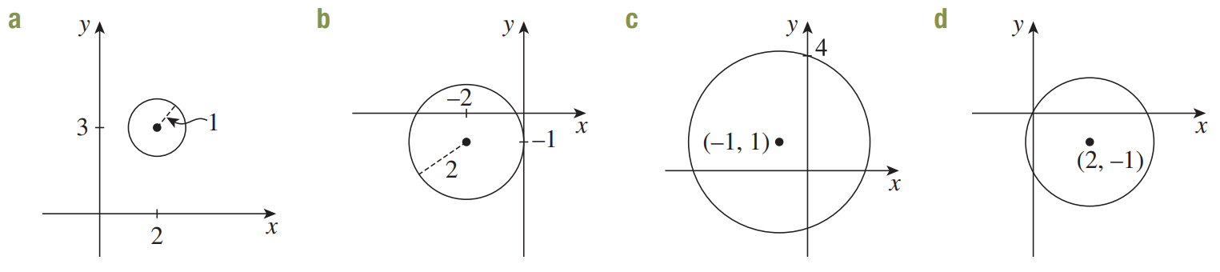  $${\left(x+2\right)}^{2}+{\left(y+1\right)}^{2}=4$$
$${\left(x+1\right)}^{2}+{\left(y-1\right)}^{2}=10$$ | $${\left(x-2\right)}^{2}+{\left(y+1\right)}^{2}=5$$

Development
- Find the equation of a circle with centre $(5,-2)$ passing through $\left(-1,1\right)$.

Distance between the centre and the point is $\sqrt{45}$, so the radius is $\sqrt{45}$.
$${\left(x-5\right)}^{2}+{\left(y+2\right)}^{2}=45$$
- A circle has centre $(4,-3)$ and one of the $x$-intercepts is at $(-\sqrt{7}+4, 0)$.
Determine the equation of the circle.

Distance between the centre and the intercept is $4$, so the radius is 4.
$${\left(x-4\right)}^{2}+{\left(y+3\right)}^{2}=16$$
- The interval joining the points $A\left(3,-1\right)$ and $B\left(-7,5\right)$ is a diameter of a circle.
  - Find the midpoint of $AB$.

$$\left(-2,2\right)$$
  - Explain why the midpoint of $AB$ is the centre of the circle.

The diameter connects two points on the circumference, passing through the centre.
Therefore, the midpoint of the diameter is the centre of the circle.
  - Find the length of the radius.

$$\sqrt{34}$$
  - Hence state the equation of the circle.

$${\left(x+2\right)}^{2}+{\left(y-2\right)}^{2}=34$$

- Find the centre of the circle with diameter $CD$, where $C=\left(2, 1\right)$ and $D=\left(8, -7\right)$.

$$\left(5,-3\right)$$
- Find the equation of a circle with diameter $KL$, where $K\left(5,7\right)$ and $L\left(-9,3\right)$

$${\left(x+2\right)}^{2}+{\left(y-5\right)}^{2}=53$$
- Find the possible equations of a circle with radius $AB$.
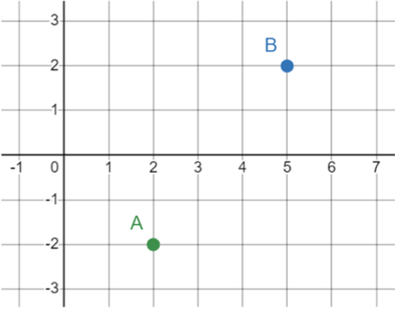

Circle with centre at A:
$${\left(x-2\right)}^{2}+{\left(y+2\right)}^{2}=25$$
Circle with centre at B:
$${\left(x-5\right)}^{2}+{\left(y-2\right)}^{2}=25$$

Completing the Square for a Circle

- Completing the Square to Find the Centre and Radius
Some questions require you to complete the square for the $x$and $y$ terms to write in the form
$${\left(x-a\right)}^{2}+{\left(y-b\right)}^{2}=r^{2}$$

- Example Sketch the graph of a circle by completing the square
$x^{2}+2x+y^{2}-6y-6=0$
$x^{2}+2x+1-1+y^{2}-6y+9-9-6=0$
$(x^{2}+2x+1)-1+(y^{2}-6y+9)-9-6=0$
${\left(x+1\right)}^{2}+{\left(y-3\right)}^{2}-16=0$
${\left(x+1\right)}^{2}+{\left(y-3\right)}^{2}=16$
Centre: $\left(-1,3\right)$, radius 4

- Guided Practice
Find the centre and radius by completing the square first.
- $x^{2}-4x+y^{2}=0$  $$\left(2,0\right) r=2$$ | - $x^{2}+6x+y^{2}-8y=0$  $$\left(-3,4\right) r=5$$
- $x^{2}+y^{2}-10x+12y=12=0$  $$\left(5,-6\right) r=7$$ | - $4x^{2}+4y^{2}-12x+20y-7=0$  $$\left(\frac{3}{2}, -\frac{5}{2}\right) r=\frac{\sqrt{41}}{2}$$

Foundation
- Determine the centre and radius of these circles by completing the square, if necessary.
- ${\left(x+1\right)}^{2}+y^{2}=4$  Centre: $\left(-1,0\right)$ Radius: 2 | - ${\left(x-1\right)}^{2}+{\left(y-2\right)}^{2}=1$  Centre: $\left(1,2\right)$ Radius: 1
- $x^{2}-10x+y^{2}=-16$  Centre: $\left(5,0\right)$ Radius: 3 | - $x^{2}+y^{2}+14x=33$  Centre: $\left(-7,0\right)$ Radius: $\sqrt{82}$
- $x^{2}-2x+y^{2}-4y-4=0$  Centre: $\left(1,2\right)$ Radius: 3 | - $x^{2}+6x+y^{2}-8y=0$  Centre: $\left(-3,4\right)$ Radius: 5
- $x^{2}-10x+y^{2}+8y+32=0$  Centre: $\left(5,-4\right)$ Radius: 3 | - $x^{2}+14x+14+y^{2}-2y=0$  Centre: $\left(-7,1\right)$ Radius: 6
- $x^{2}+4x+y^{2}-2y+1=0$  Centre: $\left(-2,1\right)$ Radius: 2 | - $x^{2}-6x+y^{2}-4y-3=0$  Centre: $\left(3,2\right)$ Radius: 4

  - Complete the square for $x^{2}+4x+y^{2}-6y+15=0$.

$${\left(x+2\right)}^{2}+{\left(y-3\right)}^{2}=-2$$
  - Explain why this is not an equation of a circle.

The radius cannot be negative.

Development
- Complete the square to sketch these circles. Show the centre, radius, and intercepts.
- $x^{2}-2x+y^{2}=0$  Centre: (1,0)  Radius: 1  $x$-intercepts:$x=0, 2$  $y$-intercepts:$y=0$ | - $x^{2}+6x+y^{2}=0$  Centre: (–3,0)  Radius: 3  $x$-intercepts:$x=-6, 0$  $y$-intercepts:$y=0$
- $x^{2}+4x+y^{2}-2y+1=0$  Centre: (–2,1)  Radius: 2  $x$-intercepts:$x=-2±\sqrt{3}$  $y$-intercepts:$y=1$ | - $x^{2}+8x+y^{2}+10y+5=0$  Centre: (–4,–5)  Radius: 6  $x$-intercepts:$x=-4±\sqrt{11}$  $y$-intercepts:$y=-5±2\sqrt{5}$
- $x^{2}-6x+y^{2}-4y-3=0$  Centre: (3,2)  Radius: 4  $x$-intercepts:$x=3±2\sqrt{3}$  $y$-intercepts:$y=2±\sqrt{7}$ | - $x^{2}-2x+y^{2} +6y-5=0$  Centre: (1,–3)  Radius: $\sqrt{15}$  $x$-intercepts:$x=1±\sqrt{6}$  $y$-intercepts:$y=-3±\sqrt{14}$

Mastery
- For what values of $k$ would the graph of $x^{2}+6x+y^{2}+k=0$ not exist?

By CTS, ${\left(x+3\right)}^{2}+y^{2}=9-k$
For circle to not exist, $9-k<0$
$$∴k>9$$
- A naval ship is at coordinates $P$ and equipped with a radar scanner that can detect objects inside the circle $x^{2}+y^{2}-80x-40y=500,$ where radius is measured in kilometres.
  - Find the coordinates of $P$.

By CTS, ${\left(x-40\right)}^{2}+{\left(y-20\right)}^{2}=2500$
$P$ is the centre of the circle, at $\left(40,20\right)$
  - Another ship is at $Q\left(60,-20\right)$ and can detect objects within a radius of 40 km.
    - Will ship $Q$ be able to detect $P$?

Distance between PQ is $\sqrt{2000}≈44.7$ km. Since Q has a radar range of 40 km, no.
    - Will ship $P$ be able to detect $Q$?

P’s radar has a range of 50 km, so yes.

- Consider the points $A\left(1,3\right)$, $B\left(3,9\right)$ and let $P\left(x,y\right)$ be a point.
  - Find an expression for the gradients of $PA$ and $PB$.

$$m_{PA}=\frac{y-3}{x-1}, m_{PB}=\frac{y-9}{x-3}$$
  - Suppose $∠APB=90°$. Show that $x^{2}-4x+y^{2}-12y+30=0$.

$$m_{PA}×m_{PB}=-1$$
$$\frac{y-3}{x-1}×\frac{y-9}{x-3}=-1$$
$$\frac{\left(y-3\right)\left(y-9\right)}{\left(x-1\right)\left(x-3\right)}=-1$$
$$\left(y-3\right)\left(y-9\right)=-\left(x-1\right)\left(x-3\right)$$
$$y^{2}-12y+27=-x^{2}+4x-3$$
$$x^{2}-4x+y^{2}-12y+30=0$$
  - By completing the square, show that this is the equation of a circle centred at $\left(2,6\right)$ with radius $\sqrt{10}$.

  - How is the point $P$ related to the circle? A sketch using DESMOS may help.
https://www.desmos.com/geometry/opfcwyddok

We have proved that if we draw any point $P$ and connect it to both A and B such that it forms a right angle at $∠APB$,
the point $P$ must lie on a circle centred at the midpoint of AB with radius $\sqrt{10}$.
This is related to the circle theorem “The angle at the circumference in a semicircle is $90°$”

Semicircles

- Semicircle Functions
Positive semicircle function  $$y=\sqrt{r^{2}-x^{2}}$$  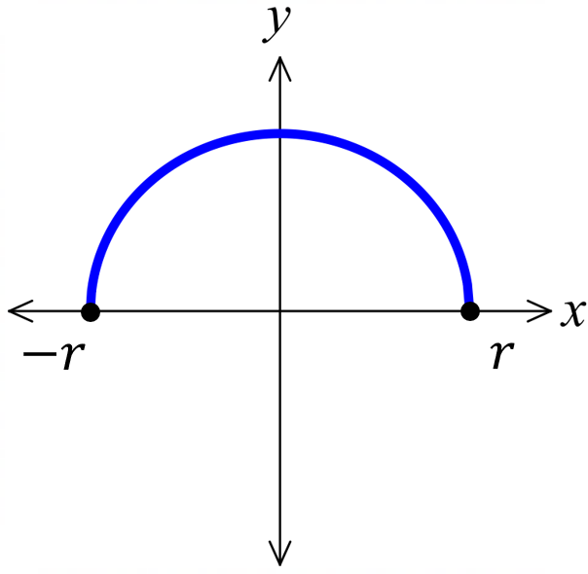 | 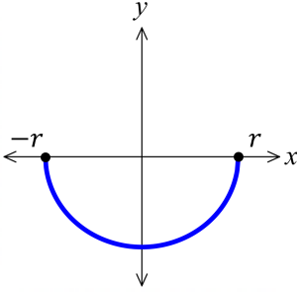  Negative semicircle function  $$y=-\sqrt{r^{2}-x^{2}}$$

- Example Sketch semicircles
$$y=\sqrt{9-x^{2}}$$  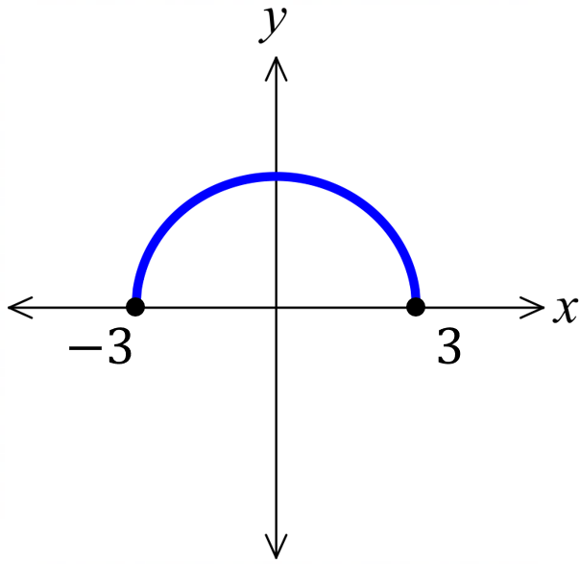 | $$y=-\sqrt{4-x^{2}}$$  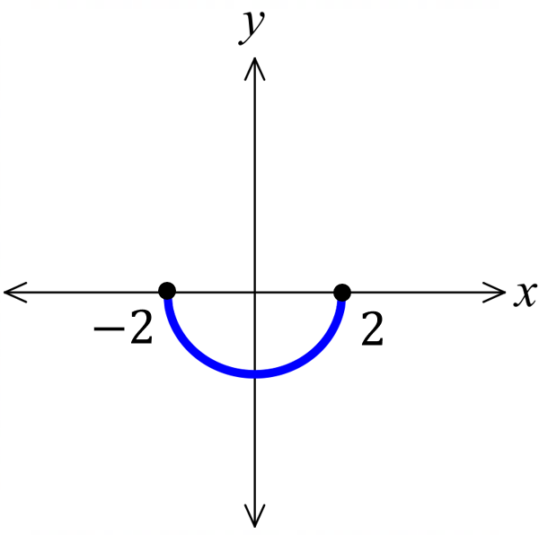

- Guided Practice
Sketch
- $y=\sqrt{4-x^{2}}$ | - $y=-\sqrt{8-x^{2}}$ |  | - $y=\sqrt{\frac{4}{9}-x^{2}}$
- Semicircle Functions
Positive semicircle  $$x=\sqrt{r^{2}-y^{2}}$$  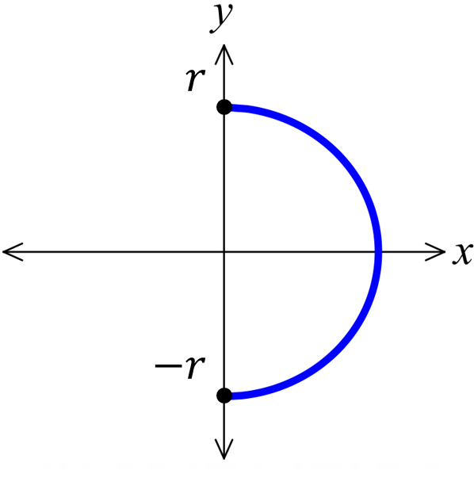 |  | 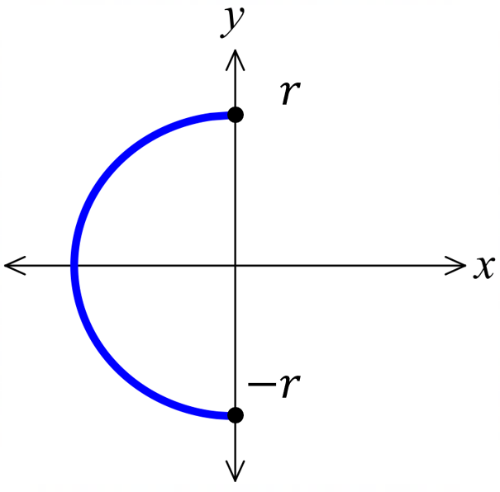  Negative semicircle  $$x=-\sqrt{r^{2}-y^{2}}$$

- Example Sketch semicircles
$$y=\sqrt{16-x^{2}}$$  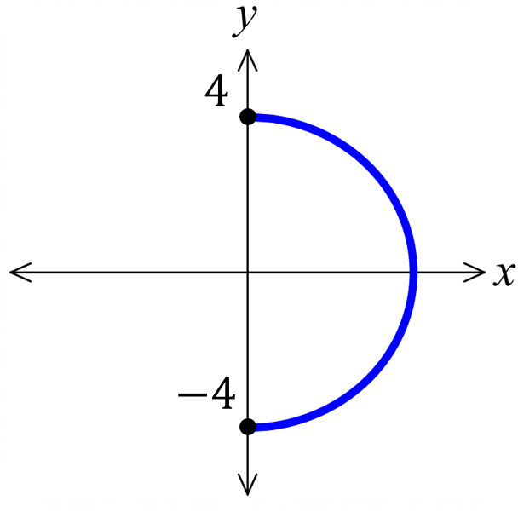 | $$y=-\sqrt{9-x^{2}}$$  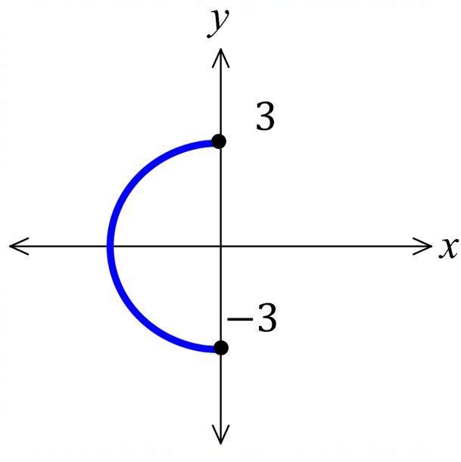

- Guided Practice
Sketch
- $x=\sqrt{25-y}$ | - $x=-\sqrt{6-x^{2}}$ | - $x=\sqrt{\frac{16}{9}-y^{2}}$

Foundation
- Sketch each semicircle. State the domain and range.
- $y=\sqrt{4-x^{2}}$  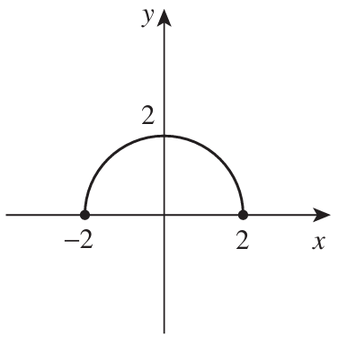  Domain:  $$\left[-2,2\right]$$  Range:  $$\left[0,2\right]$$ | - $y=-\sqrt{4-x^{2}}$  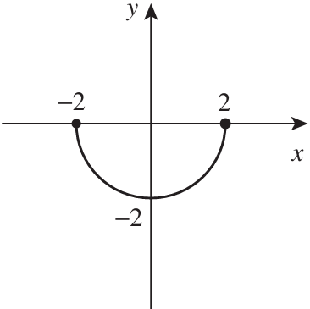  D: $\left[-2,2\right]$  R: $\left[-2,0\right]$ | - $y=-\sqrt{1-x^{2}}$  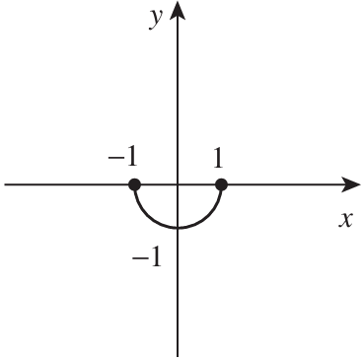  D: $\left[-1.1\right]$  R: $\left[-1,0\right]$
- $y=\sqrt{\frac{25}{4}-x^{2}}$  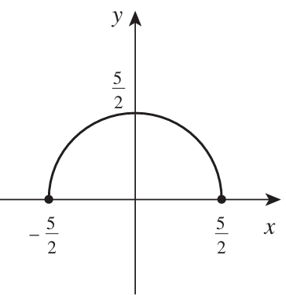  D: $\left[-\frac{5}{2}.\frac{5}{2}\right]$  R: $\left[0,\frac{5}{2}\right]$ | - $y=-\sqrt{\frac{9}{4}-x^{2}}$  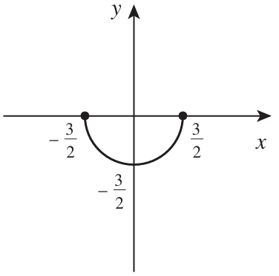  D: $\left[-\frac{3}{2}.\frac{3}{2}\right]$  R: $\left[-\frac{3}{2},0\right]$ | - $y=\sqrt{0.64-x^{2}}$  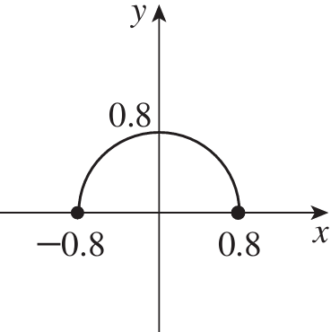  D: $\left[-0.8,0.8\right]$  R: $\left[0,0.8\right]$

- Write the equation of these semicircles.
$$y=\sqrt{9-x^{2}}$$ | 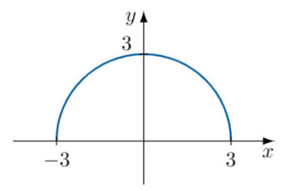  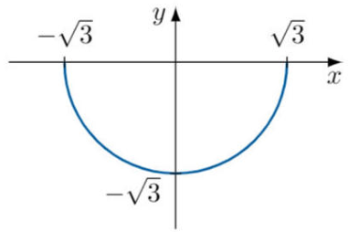  $$y=-\sqrt{3-x^{2}}$$
$$y=\sqrt{\frac{1}{25}-x^{2}}$$ | 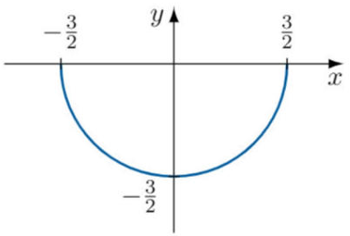  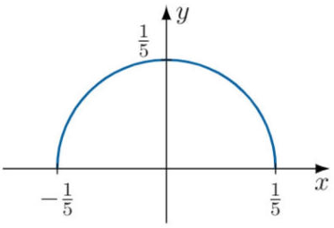  $$y=-\sqrt{\frac{9}{4}-x^{2}}$$

Square Root Functions

- Square Root Function
- The square root function $f\left(x\right)=\sqrt{x}$ is half a sideways parabola.
- Often questions will ask for the domain and range of a square root function; we can consider the equation or the graph.
$$y=\sqrt{x}$$ | $$y=\sqrt{x}+c$$ | $$y=\sqrt{x-b}$$ | $$y=-\sqrt{x}$$
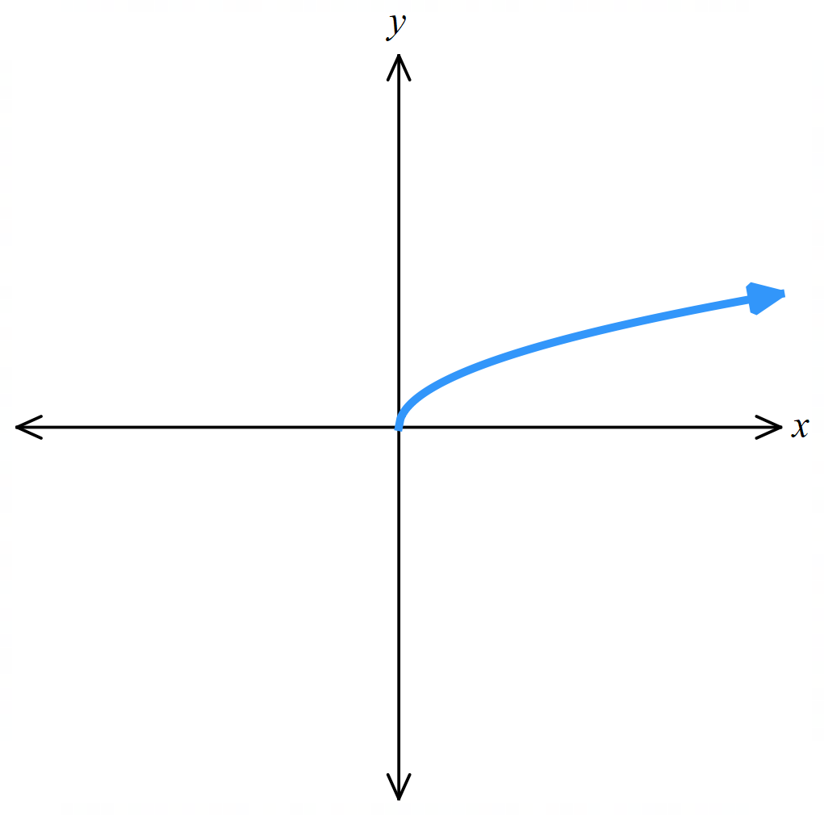 | 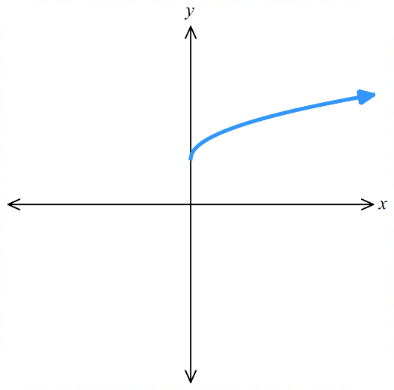 | 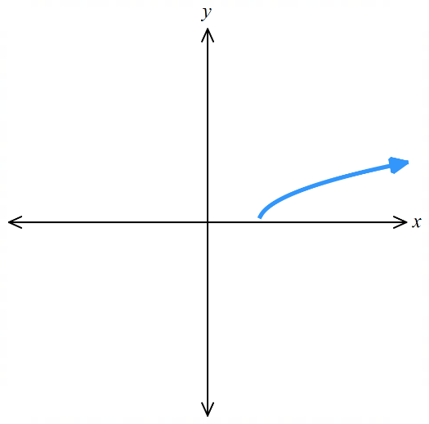 | 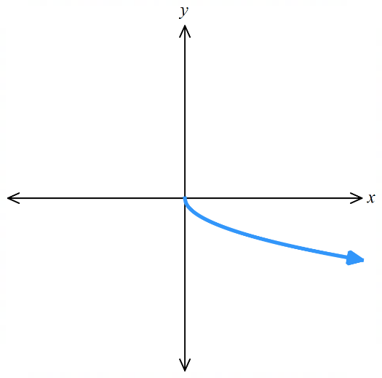

- Domain and Range of Square Root Functions
- $f\left(x\right)=\sqrt{x}$ | - $f\left(x\right)=\sqrt{x-3}$ | - $f\left(x\right)=\sqrt{x}-3$  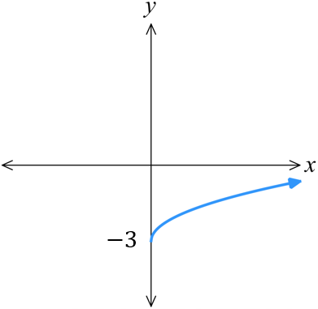  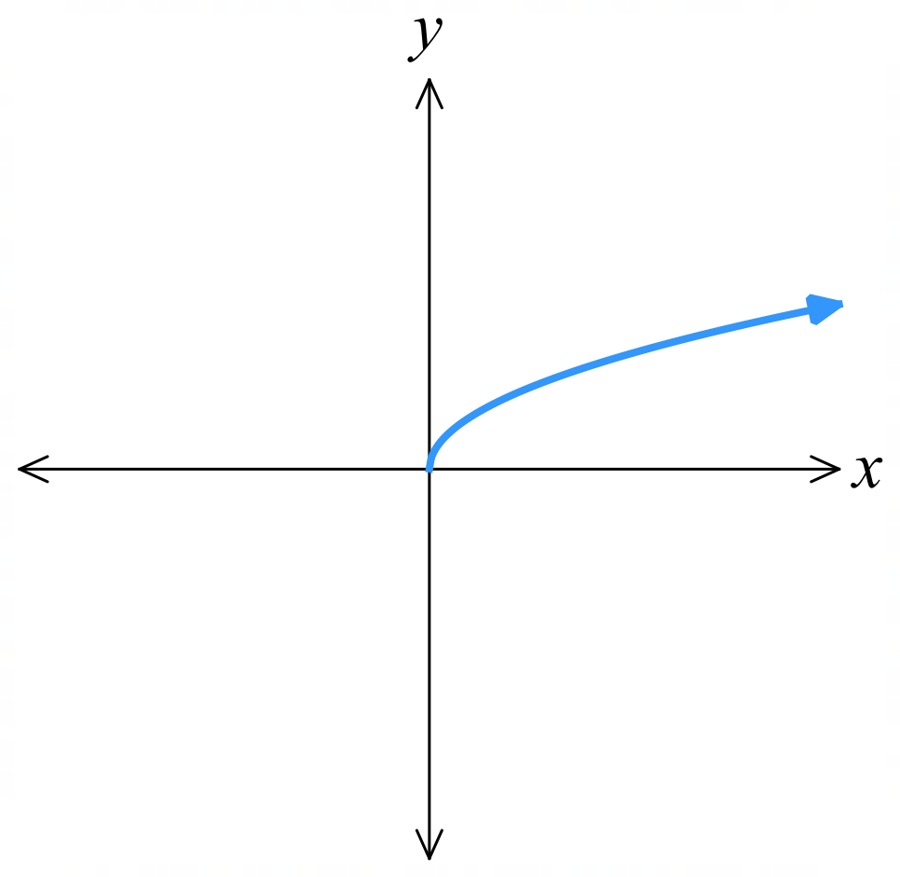  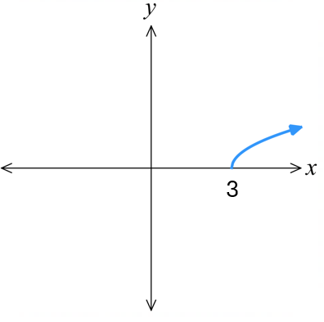
  Domain  $$x≥0$$ | Range  $$y≥0$$
  Domain  $$x≥3$$ | Range  $$y≥0$$
  Domain  $$x≥0$$ | Range  $$y≥-3$$
- $f\left(x\right)=\sqrt{x}+3$  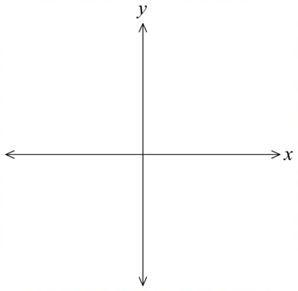 | - $f\left(x\right)=\sqrt{x+3}$ | - $f\left(x\right)=-\sqrt{x+3}$
  Domain  $$x≥0$$ | Range  $$y≥3$$
  Domain  $$x≥-3$$ | Range  $$y≥0$$
  Domain  $$x≥-3$$ | Range  $$y≤0$$

Foundation
- State the domain and range of these functions and sketch the function.
- $y=\sqrt{x}$ | - $y=\sqrt{x-2}$ | - $y=\sqrt{x-5}$
- $y=\sqrt{x+5}$ | - $y=\sqrt{x+5}+1$ | - $=\sqrt{x+5}-4$
- $y=-\sqrt{x+5}-4$ | - $y=-\sqrt{x+5}$ | - $y=2\sqrt{x+5}$
- $y=\sqrt{2x+10}$ | - $y=\sqrt{2x-10}$ | - $y=\sqrt{-x}$
- $y=\sqrt{5-x}$ | - $y=\sqrt{5-x}+3$ | - $y=-\sqrt{5-x}+3$

Points of Intersection of Two Curves

- Finding the Points of Intersection of Any Two Graphs
For any two graphs,
1. Solve simultaneously to find the $x$-coordinate(s) of the point of intersection.
2. Find the $y$-coordinate(s).

- Example Find points of intersection of a line and a hyperbola
Find the points of intersection of the line $y=4x$ and the hyperbola $y=$ $\frac{1}{x}$
1. Solve for $x$.  $4x=$ $\frac{1}{x}$  $4x^{2}=1$  $$x^{2}=\frac{1}{4}$$  $$x=±\frac{1}{2}$$ | 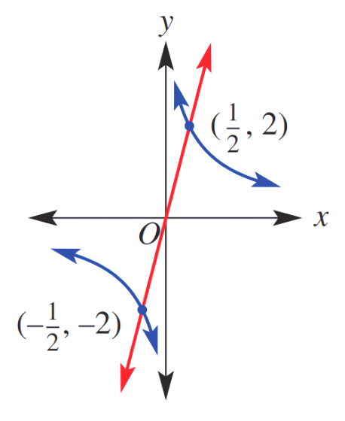  2. Find $y$ values.  Substitute $x$ into $(1)$ to find $y$ values:  When $x=$ $\frac{1}{2}$ $y=4$ $\left(\frac{1}{2}\right)$ $=2$  When $x=$ $\frac{-1}{2}$ $y=4$ $\left(\frac{-1}{2}\right)$ $=-2$  $$∴\left(\frac{1}{2}, 2\right) and \left(-\frac{1}{2},-2\right)$$

- Guided Practice
Find the point of intersection of these graphs.
- $y=-\frac{2}{x}$ and $y=-2x$
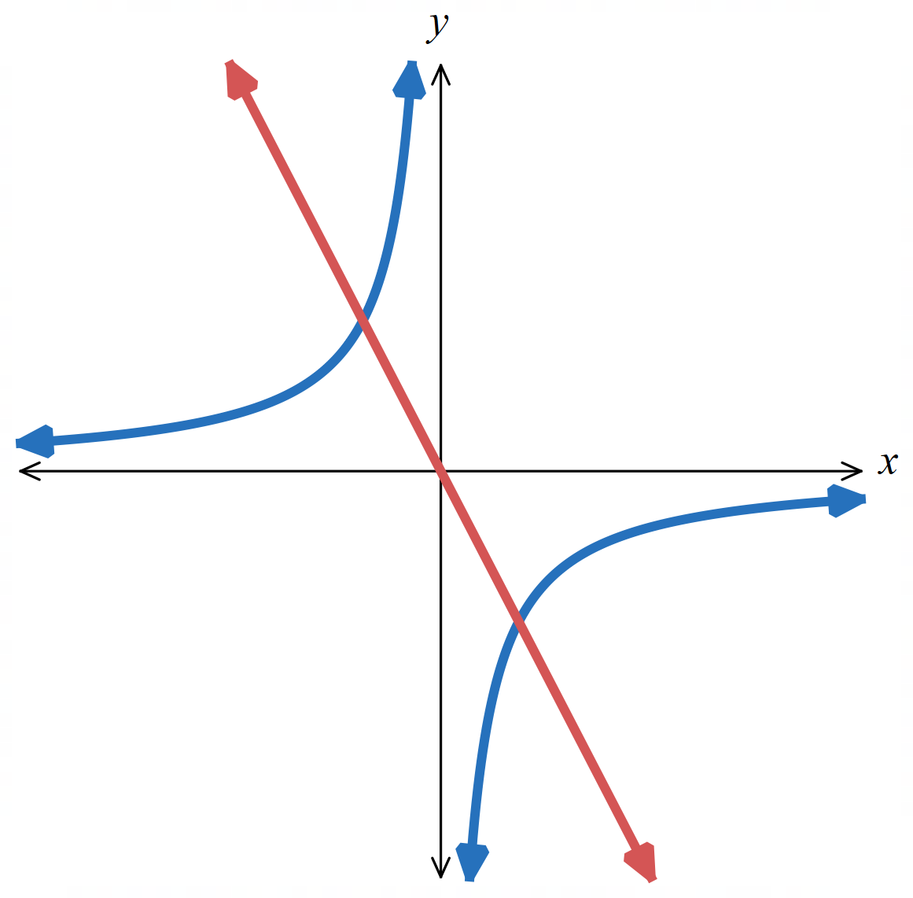

$\left(-1,2\right)$ and $\left(1,-2\right)$
- $y=$ $\frac{1}{x}$ and $y=2x$
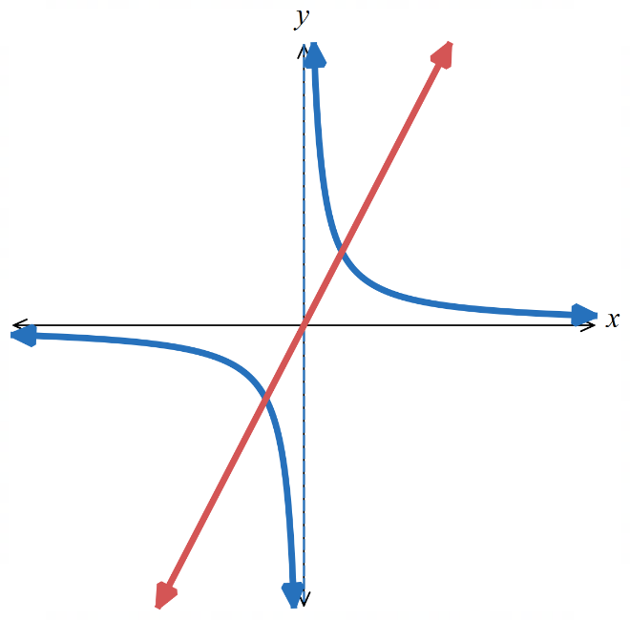

$$\left(-\frac{1}{\sqrt{2}}, -\sqrt{2} \right) and \left(\frac{1}{\sqrt{2}}, \sqrt{2} \right)$$
- Example Find points of intersection of a line and a circle
Find the points of intersection of the line $y=2x$ and the circle $y^{2}+x^{2}=4$
1. Solve simultaneously  $y=2x$ (1)  $y^{2}+x^{2}=4$ (2)  Sub (1) into (2)  ${\left(2x\right)}^{2}+x^{2}=4$  $5x^{2}=4$  $$x^{2}=\frac{4}{5}$$  $$x=±\frac{2}{\sqrt{5}}$$ | 3. Find $y$ values.  Substitute into $(1)$ to find $y$ values:  When $x=$ $\frac{2}{\sqrt{5}}$ $y=2$ $\left(\frac{2}{\sqrt{5}}\right)$ $=$ $\frac{4}{\sqrt{5}}$  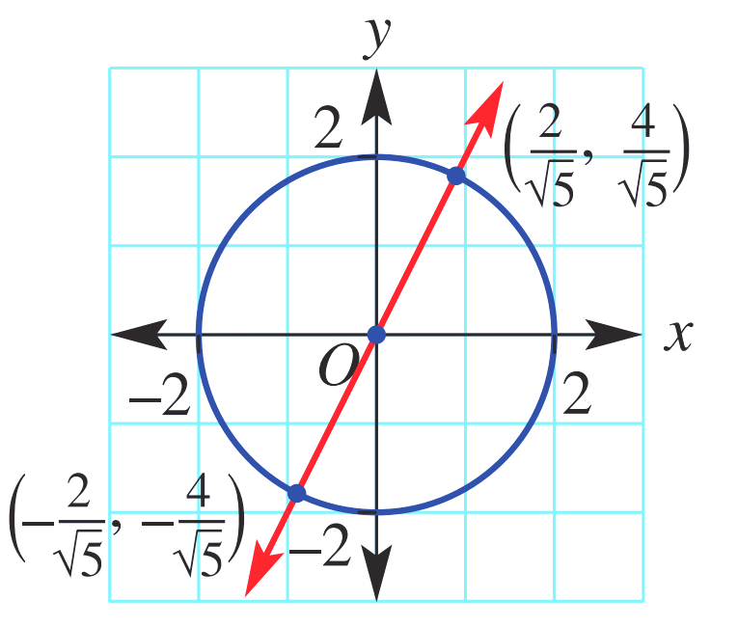  When $x=$ $\frac{-2}{\sqrt{5}}$ $y=2$ $\left(\frac{-2}{\sqrt{5}}\right)$ $=$ $\frac{-4}{\sqrt{5}}$  $∴\left(\frac{2}{\sqrt{5}},\frac{4}{\sqrt{5}}\right)$ and $\left(\frac{-2}{\sqrt{5}},\frac{-4}{\sqrt{5}}\right)$

- Guided Practice
Find the point of intersection of these graphs.
- $y=-x+1$ and
$x^{2}+y^{2}=5$
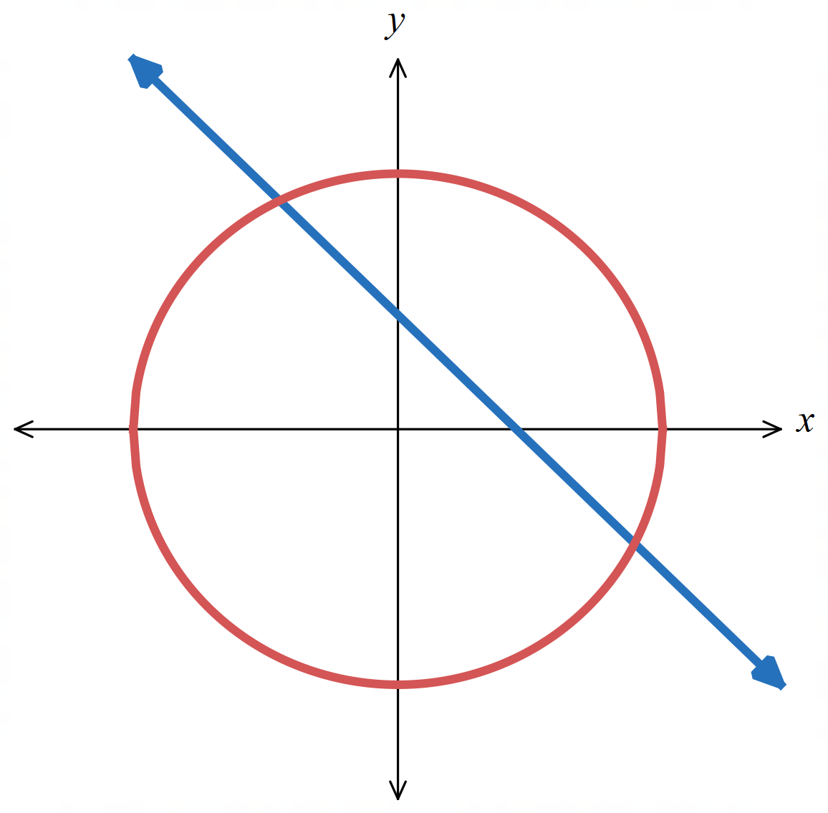

$\left(-1,2\right)$ and $\left(2,-1\right)$
- $x^{2}+y^{2}=16$ and
$y=4x$
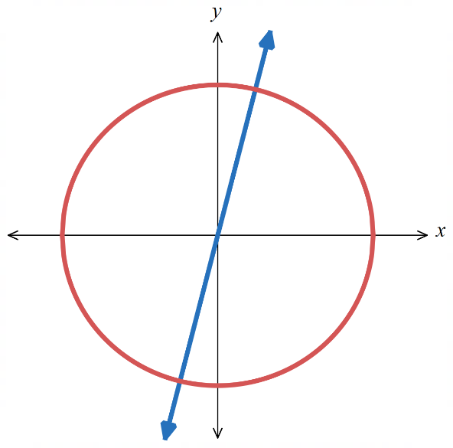

$$\left(-\frac{4}{\sqrt{17}},-\frac{16}{\sqrt{17}}\right) and \left(\frac{4}{\sqrt{17}},\frac{16}{\sqrt{17}}\right)$$

Foundation
- Find the point of intersection of these graphs. You will need to rearrange before equating.
- $y=x^{2}$ and $x=$ $\frac{y}{2}$  $\left(0,0\right)$ and $\left(2,4\right)$ | - $y+4x^{2}+x-6=0$ and $y-3x=7$  $$\left(-0.5,5.5\right)$$
- $y=x^{2}+3x-1$ and $3y=$ $x-3$  $$\left(-\frac{8}{3}, -\frac{17}{9}\right) and \left(0,-1\right)$$ | - $y-7={\left(x-2\right)}^{2}$ and $y+x=9$  $\left(1,8\right)$ and $\left(2,7\right)$
- $xy=1$ and $y=x-1$  $$\left(\frac{1-\sqrt{5}}{2},\frac{-1-\sqrt{5}}{2}\right) and \left(\frac{1+\sqrt{5}}{2},\frac{\sqrt{5}-1}{2}\right)$$ | - $x^{2}+y^{2}=4$ and $2y+x=0$  $$\left(\frac{-4}{\sqrt{5}},\frac{2}{\sqrt{5}}\right) and\left(\frac{4}{\sqrt{5}},-\frac{2}{\sqrt{5}}\right)$$

Development
- Find the point of intersection for these functions.
A sketch has been provided to help you interpret your answer.
- $y=x^{2}-2$  $y=-x^{2}+6x-6.5$  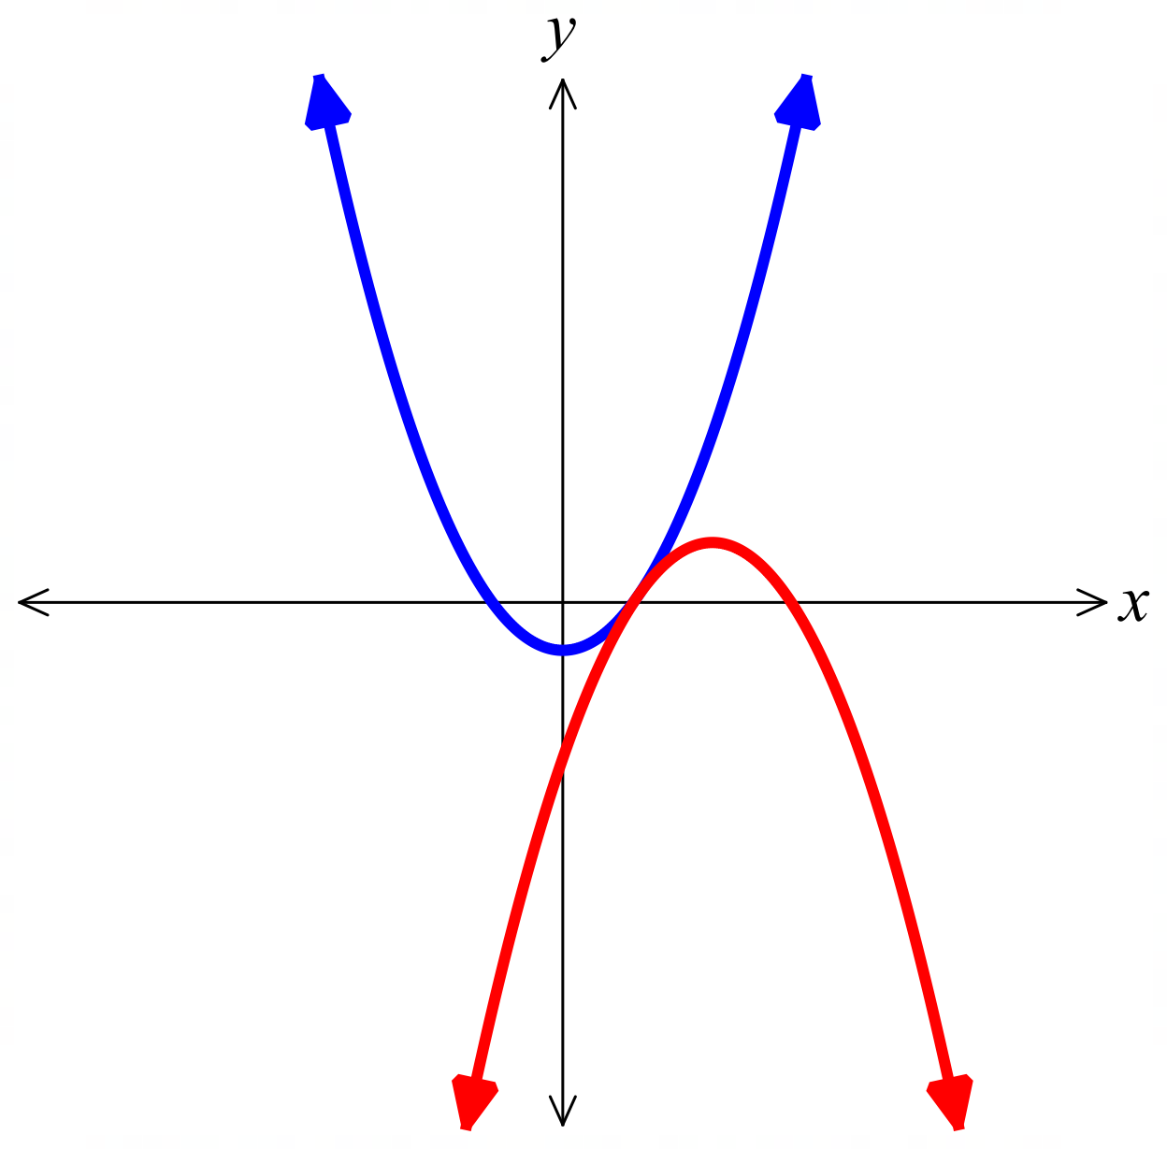  (1.5, 0.25) | - $y=x^{2}-2x+2$  $y=-x^{2}+8x+1$  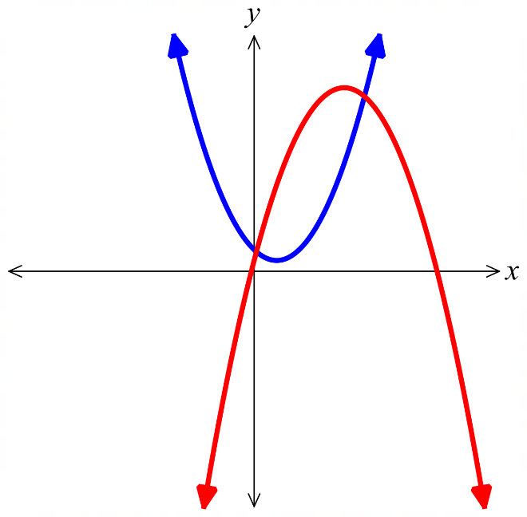  $$\left(\frac{5-\sqrt{23}}{2},9-\frac{3\sqrt{23}}{2}\right) and \left(\frac{5+\sqrt{23}}{2},9+\frac{3\sqrt{23}}{2}\right)$$
- $y=x^{2}+7$  $y=-x^{2}+6x-9$  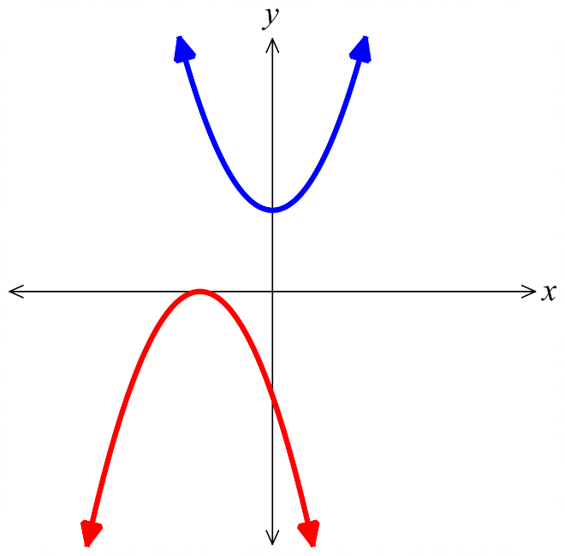  You will end up with a quadratic where $Δ<0$,  no points of intersection | - $y=x^{2}$  $y=$ $\frac{8}{x}$  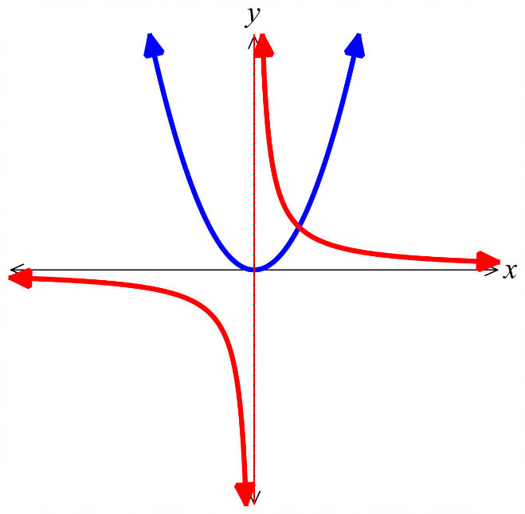  (2,4)

- The diagram shows the graph of $y=x^{3}+4x^{2}-2$ for $-3≤x≤1.5$.
By drawing a suitable straight line, solve the equation $x^{3}+4x^{2}-2=2x$ for $-3≤x≤1.5$.
Give your answer as estimates to 2 d.p.
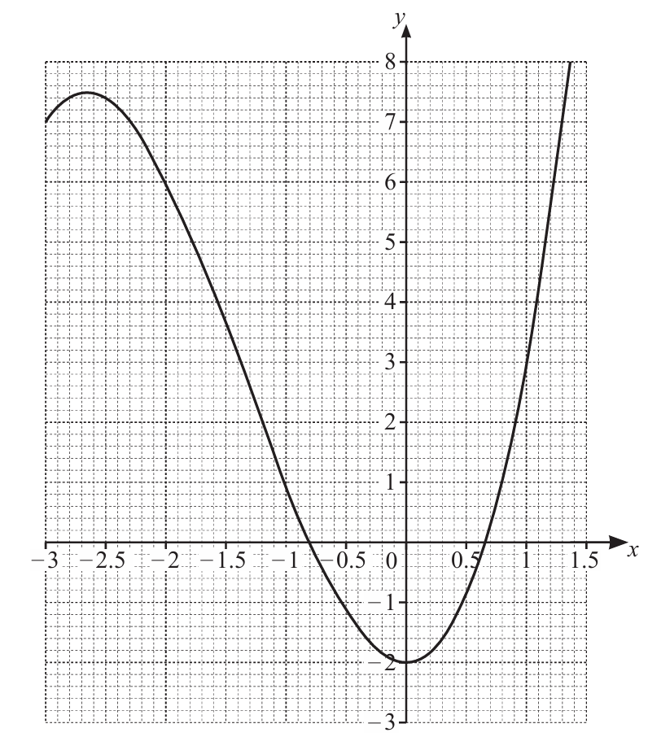

Sketch the line $y=2x$ on the same axis.
The $x$-coordinates of the points of intersection are the solution.
$x≈-0.52$and $0.88$

- The table shows some values for $y=5x^{2}-x^{3}-4$
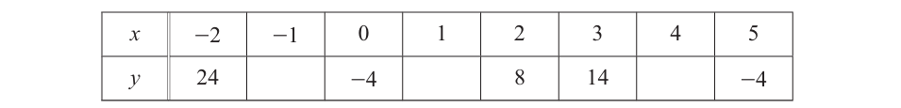
  - Complete the table.
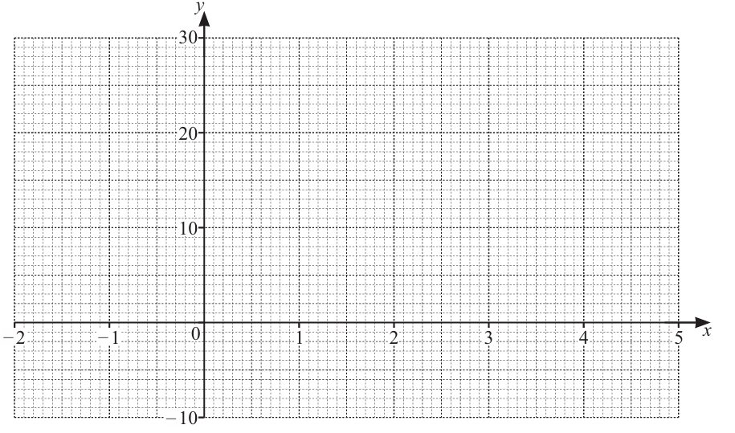
  - Sketch the graph for $-2≤x≤5$.
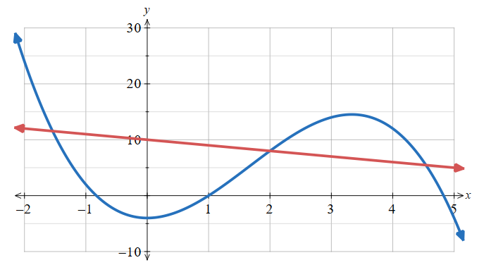

  - By drawing a suitable straight line on the grid, solve the equation $x^{3}-5x^{2}-x+14=0$
This is equivalent to solving $5x^{2}-x^{3}-4=10-x$
Draw the line $y=10-x$ and read off the points of intersection
$$x≈-1,5, 2, 4.5$$

- The table shows some values for $y=2^{x}-3$
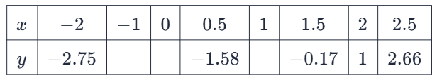
  - Complete the table.

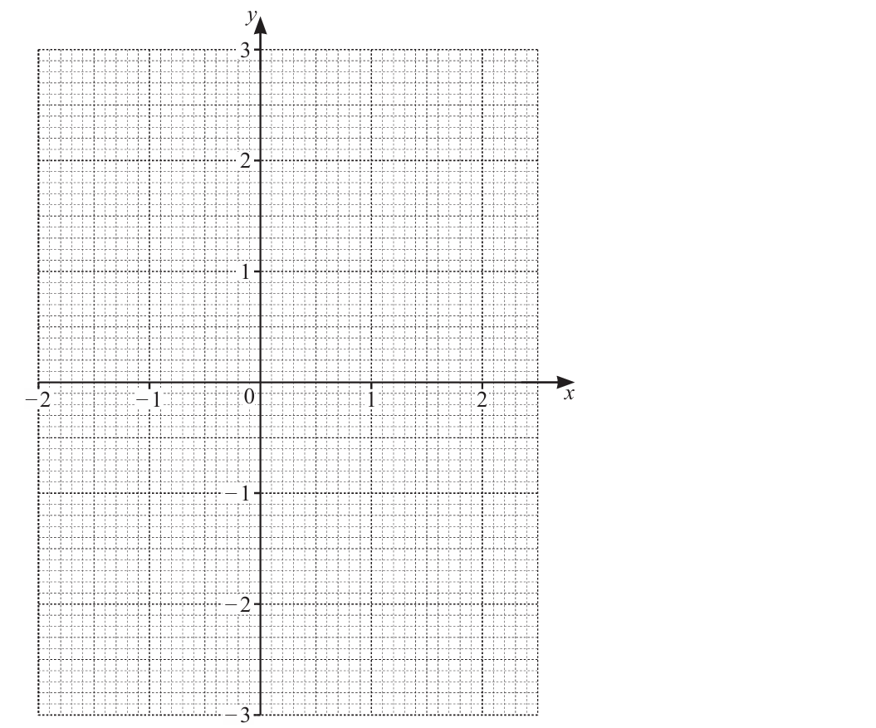
  - On the grid, sketch the graph $y=2^{x}-3$ for $-2≤x≤2.5$.
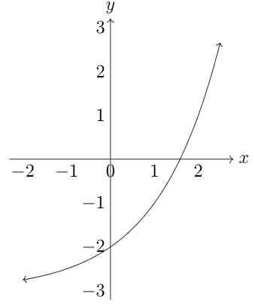

  - Use your graph to solve $2^{x}-3=2$.
Draw a horizontal line $y=2$ and read off points of intersection
$$x≈2.3$$
  - By drawing a suitable straight line, solve $2^{x}-x-1.5=0$.
This is equivalent to solving $2^{x}-3=x-1.5$
Sketch $y=x-1.5$ and read off $x$ values of points of intersection
$x=-1$ and $≈1.66$

Mastery
- Show that $y=-2x+5$ is tangent to the circle $x^{2}+y^{2}=5$.

Equate to find points of intersection:
$$x^{2}+{\left(-2x+5\right)}^{2}=5$$
$$x^{2}+4x^{2}-20x+25=5$$
$$5x^{2}-20x+20=0$$
$$Δ=b^{2}-4ac={\left(-20\right)}^{2}-4\left(5\right)\left(20\right)=0$$
$∴$ there is 1 point of intersection, hence the line is tangent to the circle.
- Show that $3x+y=6$ is tangent to the circle $x^{2}+y^{2}+4x+16y+28=0$.

Same method as above.
$$x^{2}+{\left(-3x+6\right)}^{2}+4x+16\left(-3x+6\right)+28=0$$
This simplifies to: $x^{2}-8x+16=0$
$$Δ=b^{2}-4ac={\left(-8\right)}^{2}-4\left(1\right)\left(16\right)=0$$
- The line $2x-y+3=0$ intersects the circle $x^{2}+y^{2}-4x+6y-12=0$ at two points, $D$ and $E$.
  - Find the coordinates of $D$ and $E$.

Rearrange equation of line: $y=2x+3$
Sub into equation of circle
$$x^{2}+{\left(2x+3\right)}^{2}-4x+6\left(2x+3\right)-12=0$$
This simplifies to $5x^{2}+20x+15=0$
$$∴\left(x+1\right)\left(x+3\right)=0$$
The points of intersection are $\left(-1, 1\right), \left(-3, -3\right)$
  - Hence find the length of the line segment joining $DE$.

$$DE=\sqrt{{\left(x_{2}-x_{1}\right)}^{2}+{\left(y_{2}-y_{1}\right)}^{2}}$$
$=\sqrt{2^{2}+4^{2}}=2\sqrt{5}$ units

- For the circle $x^{2}+y^{2}=4$ and line $y=mx+4$ , determine the exact values of the gradient, $m$, so that the line:
  - is a tangent to the circle (intersects the circle once)

set up equation $x^{2}+{\left(mx+4\right)}^{2}=4$
$$Δ=16m^{2}-48$$
Let $Δ=0$
$$m=±\sqrt{3}$$
  - intersects the circle at two points

$$Δ>0$$
$$16m^{2}-48>0$$
$$m<-\sqrt{3} or m>\sqrt{3}$$
  - does not intersect the circle

$$-\sqrt{3}<m<\sqrt{3}$$

  - Try to find the coordinates of the points of intersection of $y=$ $\frac{1}{x}$ and $y=-x+1$.
What do you notice?
$$-x+1=\frac{1}{x}$$
$$-x^{2}+x=1$$
$$x^{2}-x+1=0$$
There are no points of intersection; $Δ={\left(-1\right)}^{2}-4\left(1\right)\left(1\right)=-3<0$.
  - Sketch the two graphs on the same axis to visualise the scenario.

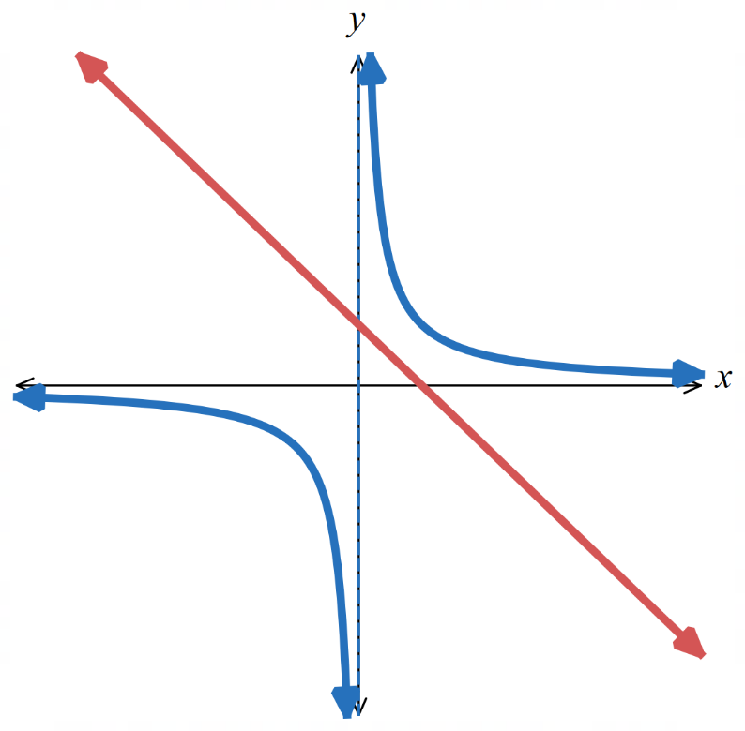

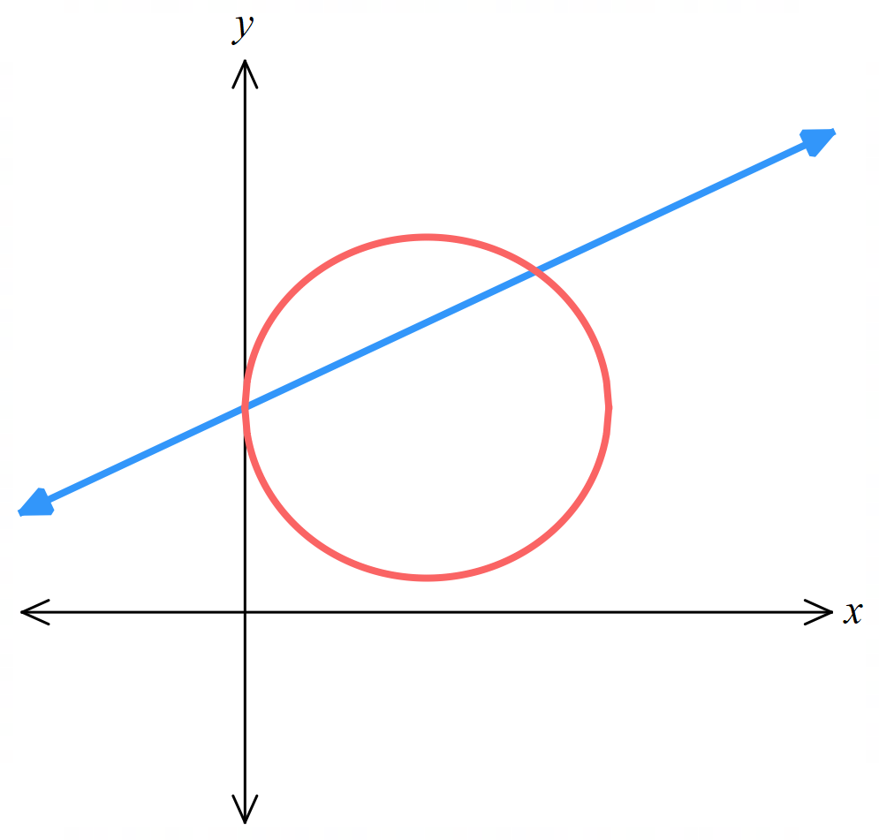
- The line $2y-x=12$ intersects the circle $x^{2}+y^{2}-10x-12y+36=0$ at the points $A$ and $B$.
A sketch is given, it would be useful to add to it as you go through parts a to d.
  - Find the coordinates of $A$ and $B$.

Using same method as previous question,
$\left(0,6\right)$ and $\left(8,10 \right)$
  - Find the equation of the perpendicular bisector of $AB$.
The perpendicular bisector of AB is the perpendicular line passing through the midpoint of AB.

Midpoint of AB: $\left(\frac{0+8}{2},\frac{6+10}{2}\right)$ $=\left(4, 8\right)$
Gradient of AB: $m=$ $\frac{10-6}{8-0}$ $=\frac{1}{2}$
$∴$ gradient of perpendicular bisector is $-2$
Using $m=-2$ and $\left(4,8\right):$ $y-y_{1}=m\left(x-x_{1}\right)$
$$y-8=-2\left(x-4\right)$$
$$y=-2x+16$$
  - The perpendicular bisector of $AB$ intersects the circle at the points $P$ and $Q$.
Find the exact coordinates of $P$ and $Q$.

Using same method as part a, $\left(5+\sqrt{5}, 6-2\sqrt{5}\right)$ and $\left(5-\sqrt{5},6+2\sqrt{5}\right)$
  - Explain why APBQ is a kite and hence find its area.
The diagonals meet at right angles, and $PA=PB$ and $QA=QB$, so it satisfies the definition of a kite.
Using distance formula:
Length of AB is: $4\sqrt{5}$
Length of PQ is: $10$
$$A=\frac{xy}{2}=\frac{4\sqrt{5}\left(10\right)}{2}=20\sqrt{5}$$

- Mr Ding used ChatGPT to generate an exam question:
‘Find the points of intersection between $y=2^{x}$ and $y=x^{2}+1$’
He checked on DESMOS and saw two ‘nice’ points of intersection at $\left(0,1\right)$ and $\left(1,2\right)$.
However, his students would not be able to find these points algebraically. Explain why.

It is not possible to solve $2^{x}=x^{2}+1$ using any standard algebraic techniques.
- [Auxiliary circle of a hyperbola]
The equation ${\left(x+y\right)}^{2}+{\left(x-y\right)}^{2}=a^{2}$ is an equation representing a circle.
  - By expanding then completing the square, find the radius of a circle in this form,
in terms of $a$.

$r=$ $\frac{a}{\sqrt{2}}$
  - What kind of curve is ${\left(x+y\right)}^{2}-{\left(x-y\right)}^{2}=a^{2}$? (hint: expand and simplify)

Hyperbola with equation $y=$ $\frac{a^{2}}{4x}$
  - Use DESMOS to sketch ${\left(x+y\right)}^{2}+{\left(x-y\right)}^{2}=a^{2}$ and ${\left(x+y\right)}^{2}-{\left(x-y\right)}^{2}=a^{2}$.
Create a slider for $a$ and experiment with values of $a$.
https://www.desmos.com/calculator/luwgidnzzy
What do you think the coordinates of the point of intersection are?

The points of intersection are $\left(±\frac{a}{2}, ±\frac{a}{2}\right)$
  - Verify this algebraically.

Start by expanding out each equation, after fully simplifying you should have $2x^{2}+2y^{2}=a^{2}$ and $4xy=a^{2}$
Substitute $y=$ $\frac{a^{2}}{4x}$ into the first equation to get $32x^{4}-16a^{2}x^{2}+2a^{4}=0$
Divide by the common factor and recognise as a perfect square: ${\left(4x^{2}-a^{2}\right)}^{2}=0$
Solve to get $x=±$ $\frac{a}{2}$
Substitute into a previous equation and solve for $y$: $y=±$ $\frac{a}{2}$

